Open the What-If Assist application (WhatIfAssist.htm) in a browser.
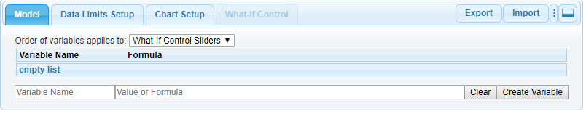
You may enter variable names, values, and formulas in the Model Tab. Example:
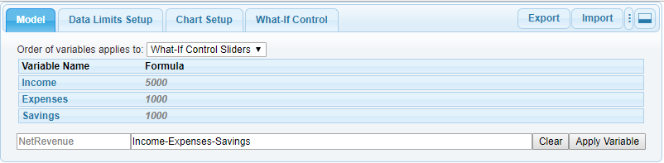
Or, click the Import tab to import data from a .CSV file. The data set must be in the form:
VariableName, ValueOrFormula, Min(optional), Max(optional)
A typical Excel spreadsheet will contain cell reference formulas as shown in the following example:
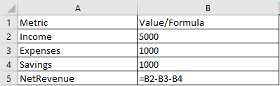
You can easily convert this Excel data to a What-If Assist compatible data set by simply replacing the formula cell references with Metric names. Optionally, data limits (minimum/maximum values) can be defined in adjacent columns for root variables. Then simply Save As .CSV file.
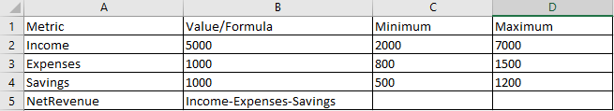

Model Tab
This section of the What-If Assist user interface provides the ability to refine the model in various ways, by adding/renaming/deleting variables, editing formulas, and changing the order of variables in the chart and/or What-If Control.
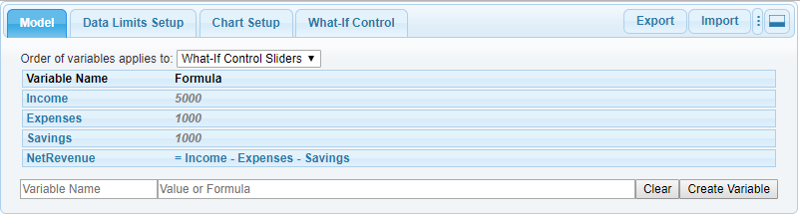
Order of variables applies to: This selection can be used to control the order in which variables appear in the what-if control or chart risers. You may drag and drop variable rows in the table to any order. If a Breakeven chart is selected in the Chart Setup tab, this selection only applies to the What-If Control Sliders.
To create a new variable, simply type the name in the “Variable Name” field and a value or formula in the “Value or Formula” field and click “Create Variable”.
A right-click menu on any existing variable shows variable edit options:
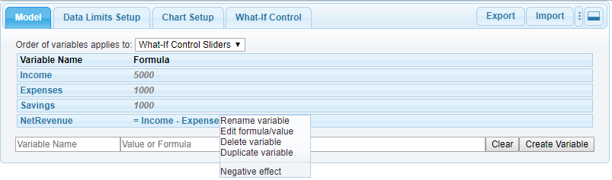
If a model contains formula(s) where the roots are mutually cancelling (e.g., C = A – B), the “Negative effect” option lets you choose which root to apply a negative change in order to change the value of the non-root in the What-If Control Tab. Example: Profit = Sales – Costs. If we are trying to improve Profit both by boosting Sales and by cutting Costs, Costs should be a "negative effect" root. But if the only way we can increase Sales is to increase Costs, perhaps by improving the quality of the product, both would be expected to rise and we would not want Costs to be a "negative effect" root.
If the model contains formula errors, the formula will be shown in red in the Model Tab and a tooltip identifies the error. Example:
. 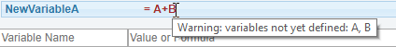

Data Limits Setup
The entries in this section confine the value of root variables to practical limits so that what-if scenarios do not produce unrealistic results. The minimum/maximum values may be specified in an imported .CSV file. If not specified in the .CSV, the application will provide default values of +/- 10%.
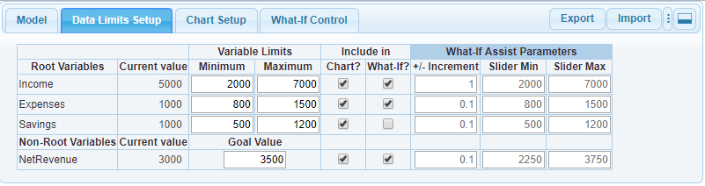
Minimum/Maximum: Minimum/maximum values can be entered as a specific value or as a percentage of the current value. The minimum value must be equal to or less than the current value. The maximum value must be equal to or greater than the current value and greater than the minimum. If percentages are used, the minimum will be set to n% less than the current value and the maximum will be set to n% greater than the current value. During what-if analysis in the What-If Control tab, the application will show a Limits Violation Error when a bottom-up analysis causes a minimum or maximum value to be breached. Note that the What-If Control tab will remain disabled until these values are defined for each root variable.
Goal: For non-root variables, you may specify a goal value that will be shown by an indicator in the What-If Control Tab. Example:
Include in Chart? Use the checkboxes to include/exclude each variable from a chart. This column will be omitted if a chart is not selected in the Chart Setup tab.
Include in What-If? Use the checkboxes to include/exclude each variable from the What-If Control tab.
+/- Increment: The values in these fields define the increment in which a variable’s value can be changed in the What-If Control tab. It cannot be zero and must either be small (less than 1/100 of (Maximum-Minimum) or evenly divisible into (Maximum - Minimum).
Slider Min/Max: These fields control the range of values shown in the slider panel in the What-If Control tab. For root variables, the default values are the values specified in the Minimum/Maximum fields. If these values are less than the variable’s limits. Left/right arrows will be shown in the What-If Control slider panel and you can extend the range of the slider. For root variables, the Slider Min/Max must be contained within the variable limits min/max.

Chart Setup Tab
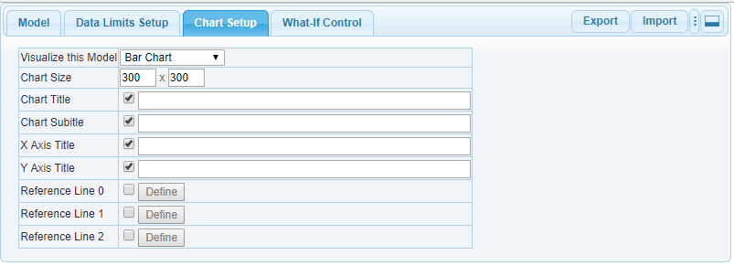
Visualize this Model: Choose a chart type from the drop-down list menu. Note that the chart type must be compatible with the data set that was created in the Model tab or Imported from a CSV file. Select None if you do not want or need to see the result of what-if exercises in a chart.
Chart Size: These fields control the size of the space allocated for a chart.
Chart Title: These fields can be used to show/hide and define a chart title.
Chart Subtitle: These fields can be used to show/hide and define a chart subtitle.
If a Breakeven chart is selected, you may enter a variable name in brackets (e.g., Break Even at {Break_Even_Units} Units) in the chart title or subtitle fields to show the value of the variable in the chart.
X/Y Axis Title: These fields can be used to show/hide and define axis titles.
Reference Line 0…3: Check the checkbox and click the Define button to define reference lines to draw in the chart.
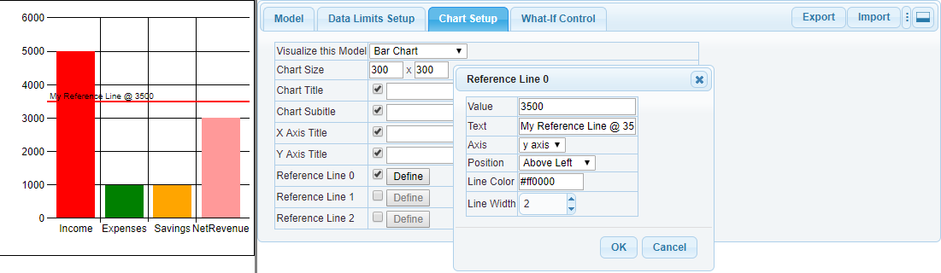
When the x-axis contains group label strings as is the case in this example, use the label string (e.g., Income) in the Value field to draw a reference line next to the riser. Reference lines are not available in pie charts.

Breakeven Chart Setup
If a Breakeven chart is selected in the Chart Setup tab, a Breakeven Chart Setup tab will be added to the user interface.
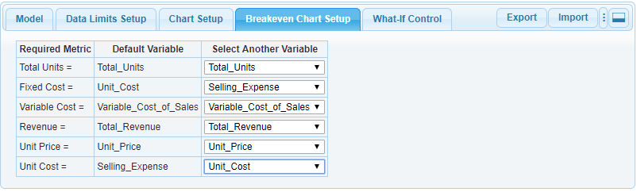
Use these fields to assign user-specific variables to metrics that are required to perform Break Even/Investment Analysis.

Waterfall Chart Setup
If a Waterfall chart is selected in the Chart Setup tab, a Waterfall Chart Setup tab will be added to the user interface.
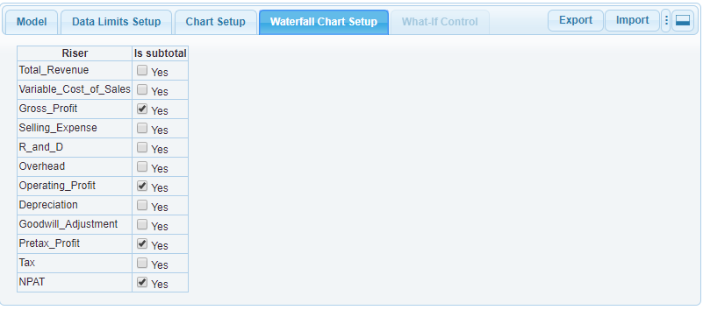
Select variables to show as subtotal risers in the chart.

What-If Control Tab
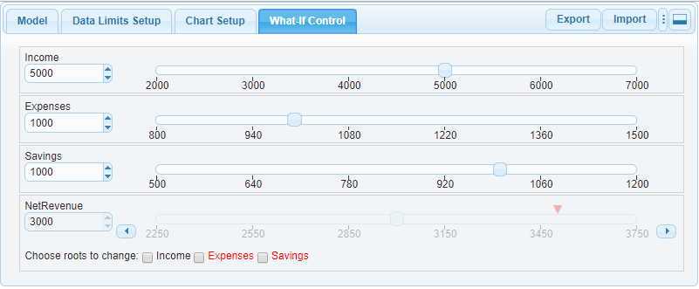
You can change the value of a variable using any of the following methods:
- Enter a new value in the text box under the variable name and press the tab key
- Click the spinner control next to the text box
- Click/drag the slider thumb
- Click on a value or tick underneath the slider control
- Click the Goal value icon
- Click anywhere in the slider track that the thumb runs over
For non-root variables, you must select a checkbox next to “Choose roots to change” to allow one or more root variables to change for a bottom up calculation. Root variables shown in red identify negative effect (one root cancels another) conditions. For more information, refer to the Negative Effect discussion in the Model tab section.
If there are more roots than can be shown, click the “more…” button to access the full list. Example:
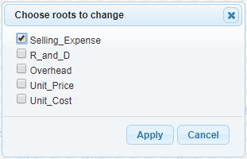
Note the down-triangle icon that appears in the NetRevenue slider panel. This represents the Goal Value that was set in Data Limits Setup. You can click on the goal marker and set the variable’s value to the goal.
When Slider Min/Max values are set to less than the variable’s min/max, you can use the left/right arrow buttons under the slider to expand the values of the slider control. Left/right horizontal buttons will not be shown if Slider Min/Max=Variable Min/Max.
If a bottom-up analysis (i.e., changing the value of a non-root), causes the value of the selected “Choose roots to change” to exceed root variable limits, the affected slider panel will show Limits Violation Errors. Example:
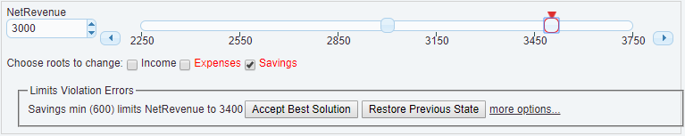
- Click the Accept Best Solution option to set the non-root and root variable to the best possible value without violating limits.
- Click the Restore Previous State button to restore previous values.
- Click the More Options button to show the Best Solution dialog with additional options.
Example:
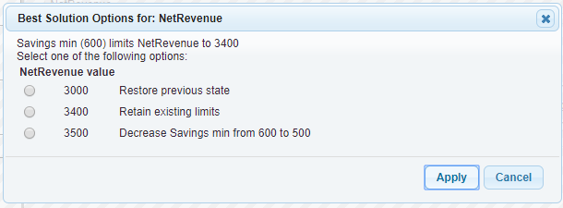

Export
At any point in What-If Assist analysis, the Export button can be used to save the current state of the model in a .CSV file or as a What-If Assist Configuration (.3if) file.
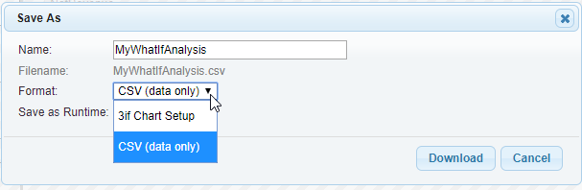
The .CSV (data only) selection saves the current value of all root variables, the formulas of non-root variables, and data limits (Minimum/Maximum) values (if specified). This file can be opened in any text editor or Imported into What-If Assist
The .3if (Chart Setup) option saves all values (same as CSV) plus any other What-If Assist configuration (e.g., Chart Type, Chart Size, Relaxed Variables selections, etc.)

User Interface Configuration
The default configuration shows the What-If Assist tabbed dialog next to the chart (if shown).
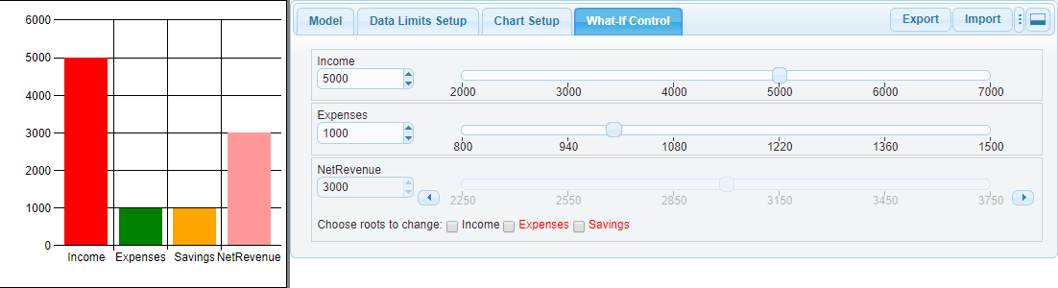
Click this button to show the user interface panel below the chart.
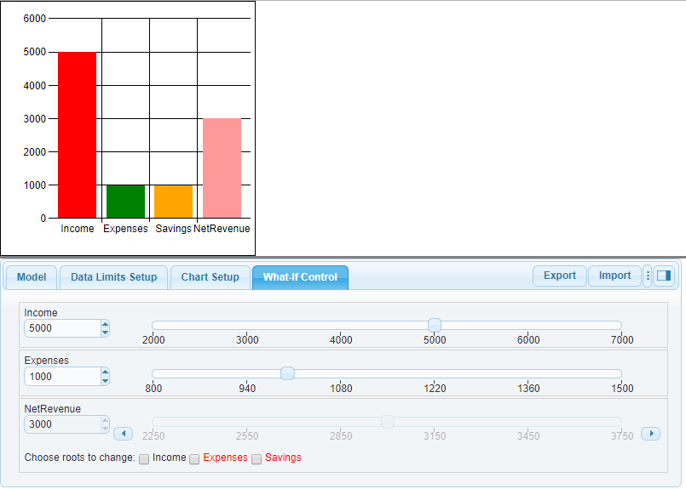
In both configurations, the line that separates the chart and tabbed dialog can be used to adjust the view to show more/less of the chart or the tabbed dialog. Vertical scroll bars can be used to show any parts of the user interface that may be hidden due to limited display space.

